**12. Kubernetes ReplicaSet - Expose and Test via Browser**

**Expose ReplicaSet as a Service**

--- **note** - Expose ReplicaSet with a service (NodePort Service), to access the application externally (from internet)

**# Expose ReplicaSet as a Service**

--- **kubectl expose rs <ReplicaSet-Name> --type=NodePort --port=80 --target-port=8080 --name=<Service-Name-To-Be-Created>**

--- **kubectl expose rs my-helloworld-rs --type=NodePort --port=80 --target-port=8080 --name=my-helloworld-rs-service**

--- **note** - **--port=80** is the service port nothing but a cluster ip port, **--target-port=8080** is the container port.

--- **--name=my-helloworld-rs-service** – the name of the service.

**# Get Service Info**

--- kubectl get service

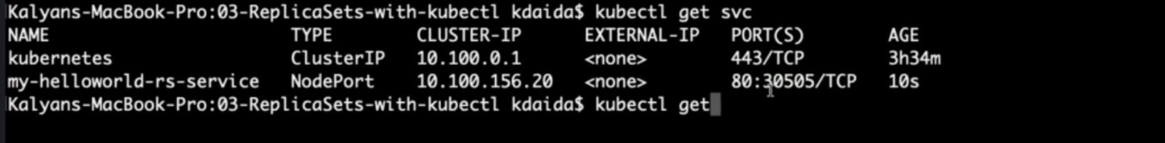

--- kubectl get svc

**# Get Public IP of Worker Nodes**

--- kubectl get nodes -o wide

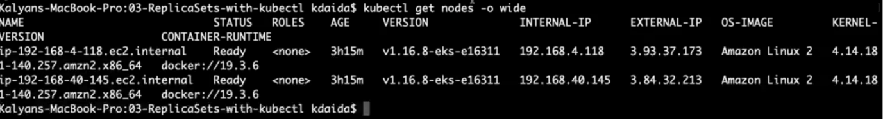

--- **note** – the external IPS are public ips. The node port is 30505.

**Access the Application using Public IP**

--- **http://<node1-public-ip>:<Node-Port>/hello**

**Test Replicaset Reliability or High Availability**

--- Test how the high availability or reliability concept is achieved automatically in Kubernetes

--- Whenever a POD is accidentally terminated due to some application issue, ReplicaSet should auto-create that Pod to maintain desired number of Replicas configured to achieve High Availability.

**# To get Pod Name**

--- **kubectl get pods**

**# Delete the Pod**

--- **kubectl delete pod <Pod-Name>**

**# Verify the new pod got created automatically**

--- **kubectl get pods (Verify Age and name of new pod)**

**Test ReplicaSet Scalability feature**

--- Test how scalability is going to seamless & quick

--- Update the replicas field in replicaset-demo.yml from 3 to 6.

**# Before change**

spec:

replicas: 3

**# After change**

spec:

replicas: 6

**Update the ReplicaSet**

**# Apply latest changes to ReplicaSet**

--- **kubectl replace -f replicaset-demo.yml**

**# Verify if new pods got created**

--- **kubectl get pods -o wide**

**Delete ReplicaSet & Service**

**# Delete ReplicaSet**

--- **kubectl delete rs <ReplicaSet-Name>**

**# Sample Commands**

--- **kubectl delete rs/my-helloworld-rs**

[or]

**kubectl delete rs my-helloworld-rs**

**# Verify if ReplicaSet got deleted**

--- **kubectl get rs**

**Delete Service created for ReplicaSet**

**# Delete Service**

--- **kubectl delete svc <service-name>**

**# Sample Commands**

--- **kubectl delete svc my-helloworld-rs-service**

**[or]**

**kubectl delete svc/my-helloworld-rs-service**

**# Verify if Service got deleted**

--- **kubectl get svc**

**Pending Concept in ReplicaSet**

--- We didn't discuss about Labels & Selectors

--- This concept we can understand in detail when we are learning to write Kubernetes YAML manifest. So, we will understand about this during the ReplicaSets-YAML section.